INTRODUCTION:
The water content (w) is also called natural water content or natural moisture content is the ratio of the weight of water to the weight of the solids in a given mass of soil. This ratio is usually expressed as percentage.
In almost all soil tests natural moisture content of the soil is to be determined. The knowledge of the natural moisture content is essential in all studies of soil mechanics. To sight a few, natural moisture content is used in determining the bearing capacity and settlement. The natural moisture content will give an idea of the state of soil in the field.
OBJECTIVE:
This test is done to determine the water content in soil by oven drying method.
THEORY:
For many soils, the water content may be an extremely important index used for establishing the relationship between the way a soil behaves and its properties. The consistency of a fine-grained soil largely depends on its water content. The water content is also used in expressing the phase relationships of air, water, and solids in a given volume of soil.
Soil mass is generally a three phase system. It consists of solid particles, liquid and gas. For all practical purposes, the liquid may be considered to be water (although in some cases, the water may contain some dissolved salts) and the gas as air. The phase system may be expressed in SI units either in terms of mass-volume or weight-volume relationships. The inter relationships of the different phases are important since they help to define the condition or the physical make-up of the soil.
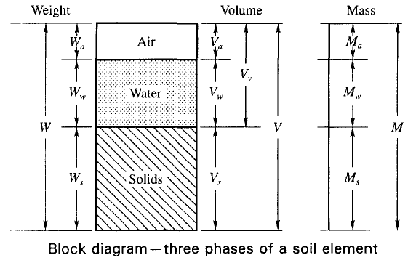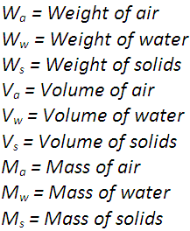

The water of the soil sample can be determined by the following method.
- Oven drying method.
- Pycnometer method.
- Sand bath method.
- Alcohol method.
- Calcium carbide method.
- Radiation method.
- Torsion balance method.
After complete drying the soil sample become,
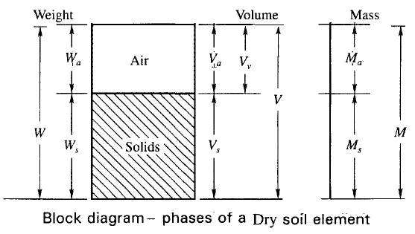
APPRATURS REQUIRED:- OVEN DRYING METHOD
- Non-corrodible air-tight container.
- Electric oven, maintain the temperature between 105 C to 115 C.
- Desiccators
- Balance of sufficient sensitivity
- Gloves
- Spatula
FIGURES:-
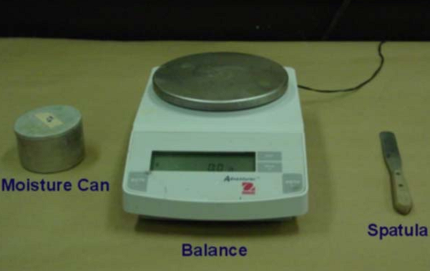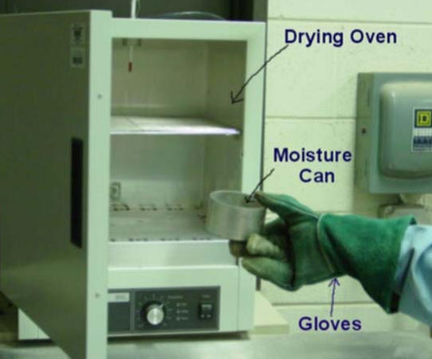
TEST PROCEDURE:-
- Clean the containers with lid dry it and weigh it (W1). " Make sure you do this after you have tarred the balance"
- Take a specimen of the sample in the container and weigh with lid (W2).
- Keep the container in the oven with lid removed. Dry the specimen to constant weight maintaining the temperature between 105⁰ C to 110⁰ C for a period varying with the type of soil but usually 16 to 24 hours.
- Record the final constant weight (W3) of the container with dried soil sample. Peat and other organic soils are to be dried at lower temperature (say 60⁰ C ) possibly for a longer period.
RUNNING THE TEST AND RECORDING THE DATA:-
- Weight of can, W₁ (g) =
- Weight of can + wet soil W₂ (g) =
- Weight of can + dry soil W₃ (g)=
The Water/Moisture content =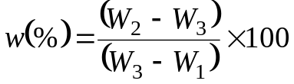

The natural moisture content of the soil sample is _ __%

Example Calculation:
Weight of can, W₁ (g) = 30.5g
Weight of can + wet soil W₂ (g) = 62.6g
Weight of can + dry soil W₃ (g) = 58.2g
The Water/Moisture content = 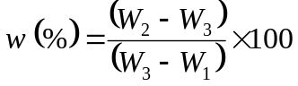

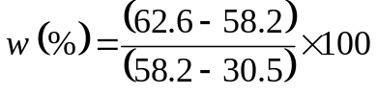

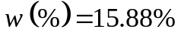

OBSERVATION TABLE:-
 | Type 1 | Type 2 | Type 3 | Type 4
Weight of can, W₁ (g)
Weight of can + wet soil W₂ (g)
Weight of can + dry soil W₃ (g)
Water/Moisture content 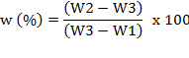

REFERENCES:-
- IS : 2720 (Part II) – 1973, Method of Test for soil : Part II
- Soil Mechanics and Foundations.

GRAPHS:-
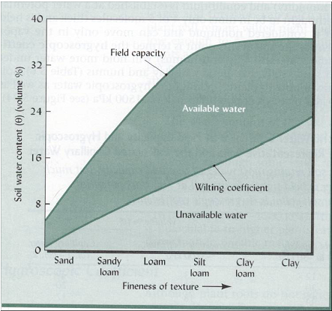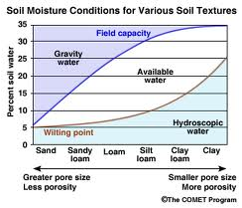
Relationship of soil texture soil water content.

QUIZ:
- Water content is also called? (Moisture content)
- Which method is mostly used to determine the water content in field?
- What is water content for clay soil?
- On which factor water content is depended?
- Water Content determined by direct weighing, this method is called? (Gravimetric)
- Maximum water content maintained in the soil without the water draining rapidly is called? (Field capacity)
- Wilting point means? (no water in soil)
- Ground Penetrating Radar (GPR) method is also used for measuring water content (True / False)
- Name different types of soil textures? (Very Fine, Fine, Medium, coarse)
- The percentage of water remaining in an air-dry soil is called (Hygroscopic coefficient)

Objective:

- Soil water content is expressed on what basis
- Gravimetric
- volumetric
- Both a and b
- none

- Water content affects
- Strength and settlement of soils
- Sensitivity
- Relative dendity
- None

- The water content of clays are generally ________ sand and silts
- Greater than
- Equal to
- Less than
- None
- The standard method of determining water content is
- Oven-drying method
- Calcium carbide method
- Alcohol method
- Pycnometer method

- Water content for dry soil is equal to
- 0
- <0
- >0
- <=0

- Pycnometer is used to determined
- Water content and void ratio
- Specific gravity and dry density⁰⁰
- Water content and specific gravity
- Void ratio and dry density

- The water content of soil is defined as the ratio of
- Volume of water to volume of given soil
- Volume of water to volume of voids in soil
- Weight of water to weight of air voids
- Weight of water to weight of solids of given mass of soil

- Water content of a soil sample is the difference of weight of given sample at the temperature and the weight determined after drying it for 24hrs at temperature ranging from ⁰c
- 80⁰ c to 90⁰c
- 90⁰c to 95⁰c
- 95⁰c to 100⁰c
- 105⁰c to 110⁰c

- Water content for saturation soil is
- =0
- <0
- >0
- <=0
- The ratio of the weight of given volume of soil solids to the weight of an equal of distilled water at the given temperature, is known
- Porosity
- Specific gravity
- Void ratio
- Water content
- Water content w in %
- W<0
- 0<w>100
- 0≤ w ≥100
- W≥100

Note: This quiz will be in choosing the best answers; score will be given once the test is done. More questions can be included if needed.

PART – 2
ANIMATION STEPS

It consists of step wise animation.

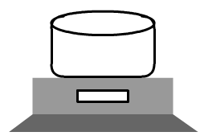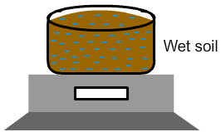
STEP – 1 STEP – 2
Step – 1: Weight of empty container.
Step – 2: Weight of sample soil with container.

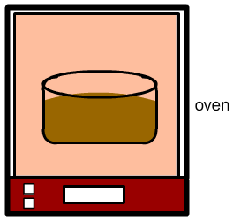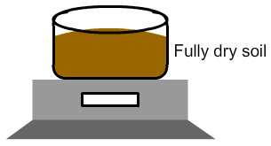
STEP – 3 STEP – 4
Step – 3: Drying of sample soil in oven with consistent temperature.
Step – 4: Weight with dried sample soil and container.

PART – 3
VIRTUAL LAB FRAME
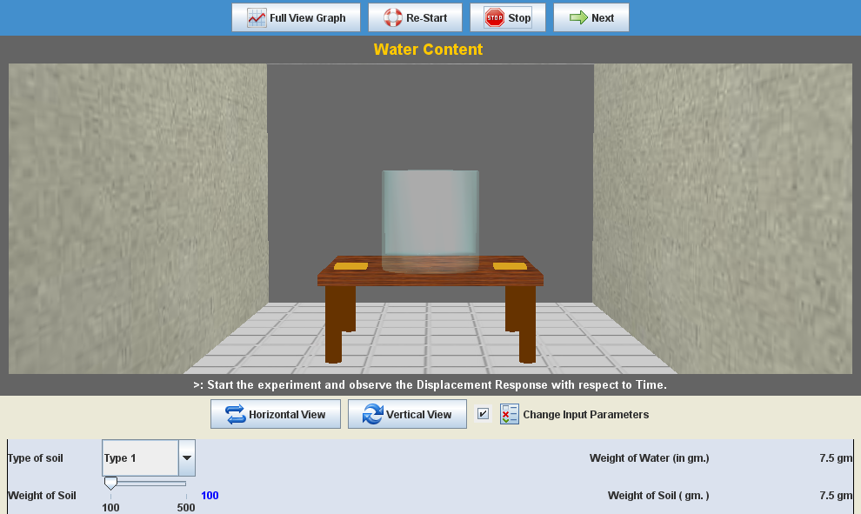
LABORATORY ROOM CONSISTS:
- Table
- Can
- Ovan
- Weight Balance

INPUT:
- Type of Soil
- Weight of Sample Soil

OUTPUT:
- Weight of Dried Soil
- Water content of the Soil

Types of graphs shown once the experiment virtually done
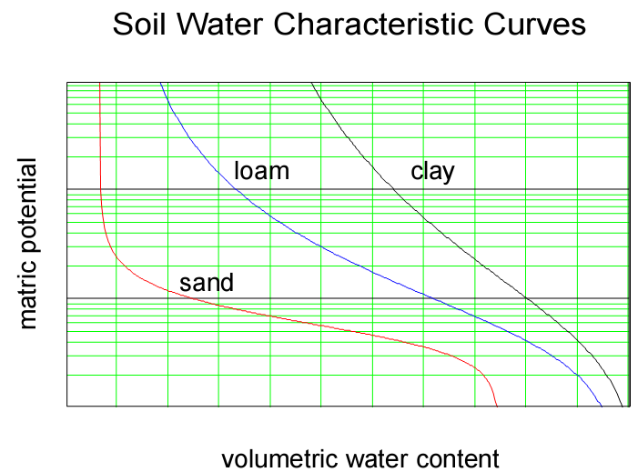
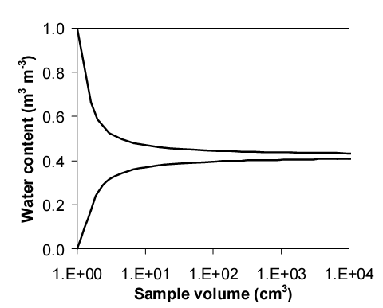
Example bounds on likely sample values as sample volume increases. The representative elemental volume (REV) can be chosen according to the acceptable variability in sample values.

